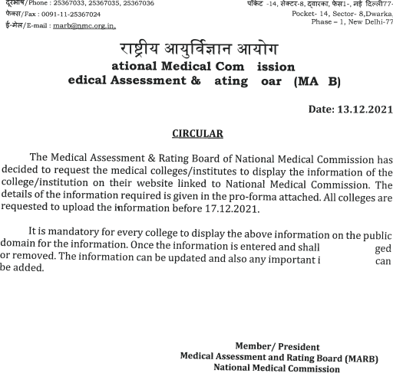
Pro-Forma for Display of Information on the College Website
The Following Details are mandatory to be filled up by the Medical College and displayed on their website (once entered should be updated without removal of data)
S No. | Information of the medical  college/institution  Year of Inception:  Government/private:
1. | Name
2. | Address with pin code
3. | University address with pin code
4. | Official website
5. | Dean/ Principal/ Director
6. | Mobile Number
7. | Email ID of Dean
8. | Hospital
9 | Date and Year of Registration of the Hospital (DD/MM/YYYY)
10. | Number of Beds
11. | Number of Beds for emergency
12. | Date of the First Letter of  Permission(LoP) of MBBS  (DD/MM/YYYY) & number of seats
13. | Status of Recognition
14. | Number of MBBS and PG broad specialty and super specialty students admitted in this session* | MBBS:  MD/MS:  DM/MCh:

15. | Inpatients registered and admitted (01.01.2021- 31.12.2021)** | 2021  2020  2019
16. | Outpatients registered  (01.01.2021-31.12.2021)** | 2021  2020  2019
17. | Number of Deaths reported to the Municipality/ village register | 2021  2020  2019
18. | Address and pin code of the  Corporation/village where the Death records are reported
19. | Website link/ email ID/ hyperlink of the corporation in case Death Records are reported
20. | Number of Births reported | 2021  2020  2019
21. | Address and pin code of the  Corporation/village where the Birth records are reported
22. | Website link/ email ID/ hyperlink of the corporation in case Birth Records are reported
23. | Number of Rooms in Men’s Hostel and students accommodated
24. | Total Number of Rooms in Women’s Hostel and students accommodated
25. | Name of the Grievance Redressal Officer (PIO & CPIO):
26. | Address with Pin code

27. | Telephone Number  Email Id
28. | Grievances reported | 2021  2020  2019

29. Details of Post- Graduation Courses offered
Post  Graduate  Course | Year of  Commencement of the Course | Number of Students  Currently pursuing the Course | Number of  Students admitted in the current  session

30. Department wise list of Faculty Members
Department | Name of  the  faculty  Qualification  IMR  Number | Current  Designation &  Date of  promotion | Nature of  employment  Regular/  permanent or contract/outsourced | Details of  Service in  the Last 5  years |  |  |  |  | Number  of  lectures  taken/year.  Topics  covered
 |  |  |  | 1 | 2 | 3 | 4 | 5
Ophthalmology | Dr.Rakhi Bandyopadhyay  MBBS, MS,  Fellowship in Pediatric Ophthalmology and Strabismus, Aravind Eye Hospital, Madurai  IMR NO. 49735 WBMC | Professor  11 11.2019 | Permanent | Associate  Professor  B.S.M.C, Bankura | Associate  Professor  B.S.M.C, Bankura | Associate Professor  B.S.M.C.  Bankura till 10.11.19  Professor  B.S.M.C. till 20.12.19  Professor  D.H.G.M.C.  From 23.12.19 onward | Professor  D.H.G.M.C. | Professor  D.H.G.M.C.
 | Dr Apala Bhattacharya  MBBS, M.S.(Ophthalmology)  Registration No.61649(West Bengal Medical Council) | Associate. Professor  11/11/2019 | Regular | Asstt.Prof  RIO, MCH’Kolkata | Asstt.  Prof  RIO, MCH,Kolkata | Assoc. Prof.  RIO, MCH,Kolkata  (11.11.2019)  Assoc. Prof.  DHGMCH  16.12.2019 | Assoc. Prof.  DHGMCH | Assoc. Prof.  DHGMCH
 | Dr.Briti Sundar Naiya  MBBS,  MS(Ophthalmology)(RIO)  Registration No.69663  (West Bengal Medical Council) | Tutor  30/07/2019 | Permanent | Tutor | Tutor | Tutor
 | Dr. Biswajit Sarkar  M.S.(Ophthalmology)  59594wbmc | Tutor/ Demonstrator in Ophthalmology  27/02/2021 | Permanent | MOTR | MO  Supy | MO  Supy | MO  Supy | Tutor/  Demonstrator  Of  Ophthalmology

N.B.
1. Publications by faculty should be attached as annexure.
2. Publications should be quoted in Vancouver referencing style.
3. Medical Educator Training/ research methodology and dates *To be updated every new session/academic year
**To be updated on 1st October each year
ANNEXURE-1
Sr.  No | Faculty  Name |  | Publication in Vancouver referencing style. |  | Pubmed  Indexed Yes/No |  | Scopes
 | Dr.Rakhi Bandyopadhyay |  | 1.Bandyopadhyay R,Shelby S,Vijayalashmi P. Surgical outcome in monocular elevation deficit: A retrospective interventional study. Indian J Ophthalmology 2008;56:127-33  2.Bandyopadhyay,R, Chatterjee A et al  Frontal osteomyelitis presenting as upper lid ectopic. Saudi J Ophthalmology 2015;29:238-41  3.Bandyopadhyay R,Halder D Macular thickness and volume among children with strabismic amblyopia attending Ophthalmology out patient department of bankura sqmmilani medical college and hospital, West bengal. International J scientific research 2019; 8:48-51  4.Bandyopadhyay R, Mandal T, Sarkar P. Study of serum total thiol levels and lipid peroxidation as indicator of oxidative stress in patients of acute central serous retinopathy. J Evolution Med. Dent. Sci.2019;volume 8:issue 1:19-23  5. Bandyopadhyay R et al. A study on maternal serum total thiols and highly sensitive C reactive protein as indicator of oxidative stress and inflammation in preclampsia and their correlation with ophthalmic manifestations. J Evolution Med Dent Sci 2019.vol 8: 1825-29 |  | Yes  Yes  Yes  Yes  Yes |  | Yes
 | Dr.Apala Bhattacharya |  | - Bhattacharya A, Anchal K, Bhattacharya,Ghosh AK. Myopia Related Retinal Changes A Study In Eastern India .Indian Journal of Basic and Applied Medical Research; June 2017. Vol.-6( 3) : 217-225  - Bhattacharya A ,Bhaduri G, Bandyopadhyay AK. Central Corneal Thickness-An important variable for prognostication in Primary Open Angle glaucoma; A Kolkata based study in Eastern India. Indian Journal of Basic and Applied Medical Research; June 2016: Vol.-5, (3).552-562  3.Bhattacharya A , Bhattacharya A , Kumari A. Mobius syndrome: The clinician’s dilemma: A case report. Indian Journal of Basic and Applied Medical Research; September 2015: Vol.-4(4) :113-118 |  | No  No  No
 | Dr.Briti Sundar Naiya |  | Naiya BS.A study of ocular morbidity and ocular surface status in street children of Kolkata and its suburbs. Current Indian Eye Research 2017;4:13-6. | Yes
 | Dr.Biswajit Sarkar | Sarkar B, Kumari E, Dalal S, et al. Ocular factors associated with resistance to the development of diabetic retinopathy in type 2 diabetic patients. J. Evid. Based Med. Healthc. 2019; 6(31), 2134-2137. DOI:10.18410/jebmh/2019/435

